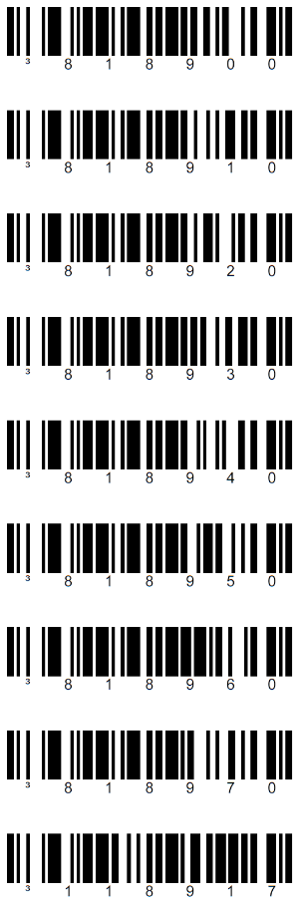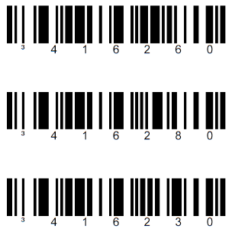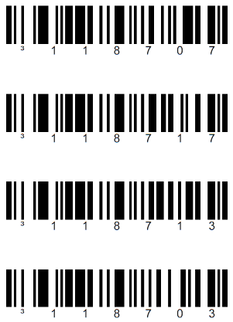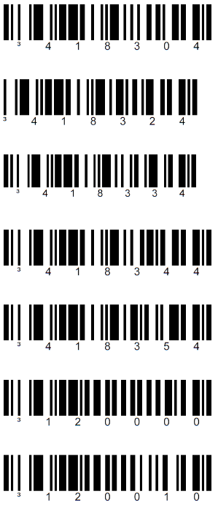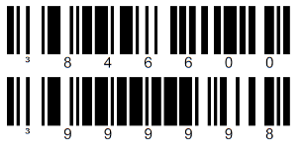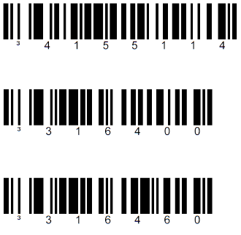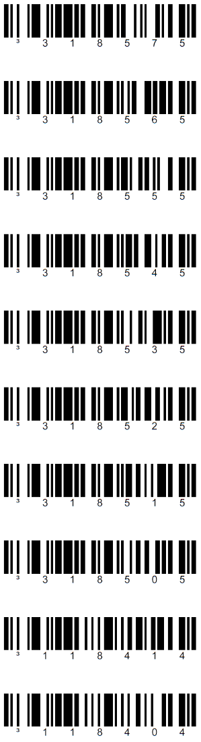

Redmine Public Wiki > 9000 BarcodeDokument + Geräte > Honeywell-MS9540-Control.docx

**Honeywell  
MS9540  
VoyagerCG**

**USA \***

Switzerland

Germany

No Symbol Time  
wiederholtes Scannen

1000 ms  
 **875 ms \***

750 ms

625 ms  
  
500 ms

375 ms

250 ms  
  
Infinite

**Enable Factory Defaults  
+ Recall Defaults**

**PRODAT-Default**

**Default \*** (Reset)

Page) PDF-Page  
 29) 36 Beep  
 56) 63 Language  
 68) 75 USB  
 78) 85 Button  
 79) 86 ScanMode  
 80) 87 Dupplicate  
 89) 96 Reset

**Enable USB Interface \***

**USB Keyboard Emulation \***

USB Serial Emulation  
(bi-directional)

Enable Fast Beep

**Disable Fast Beep \***

Optional 4

Optional 5

Optional 6

Optional 1

Optional 2

Optional 3

**Normal Beep \***

No Beep

**Scan Normal \*** (3-10s)

Scan Blinky (60s)  
  
Scan Continuous Blinky

Scan On-Shot (scan and off)

Scan Manual (button-click)

**Button Normal Timeout \***  
  
Button 0.5 Seconds

Button (CodeGate)  
Active in Stand

**Inactive in Stand \***

**Active in Hand \***

Inactive in Hand